Day 4
Installed MONGO DB.
Installed Mongo Shell.

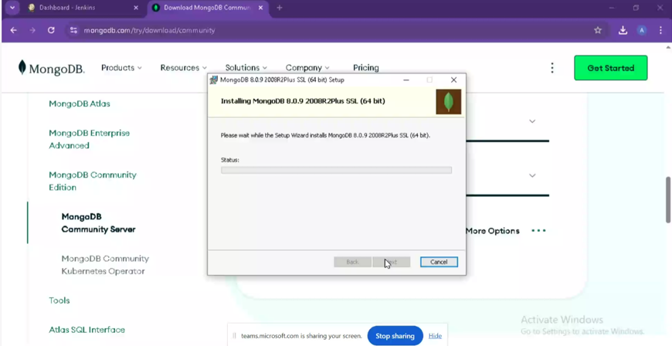
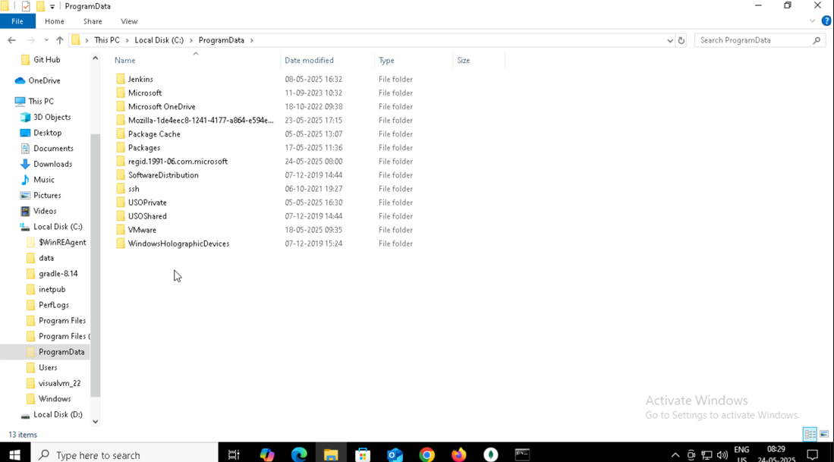
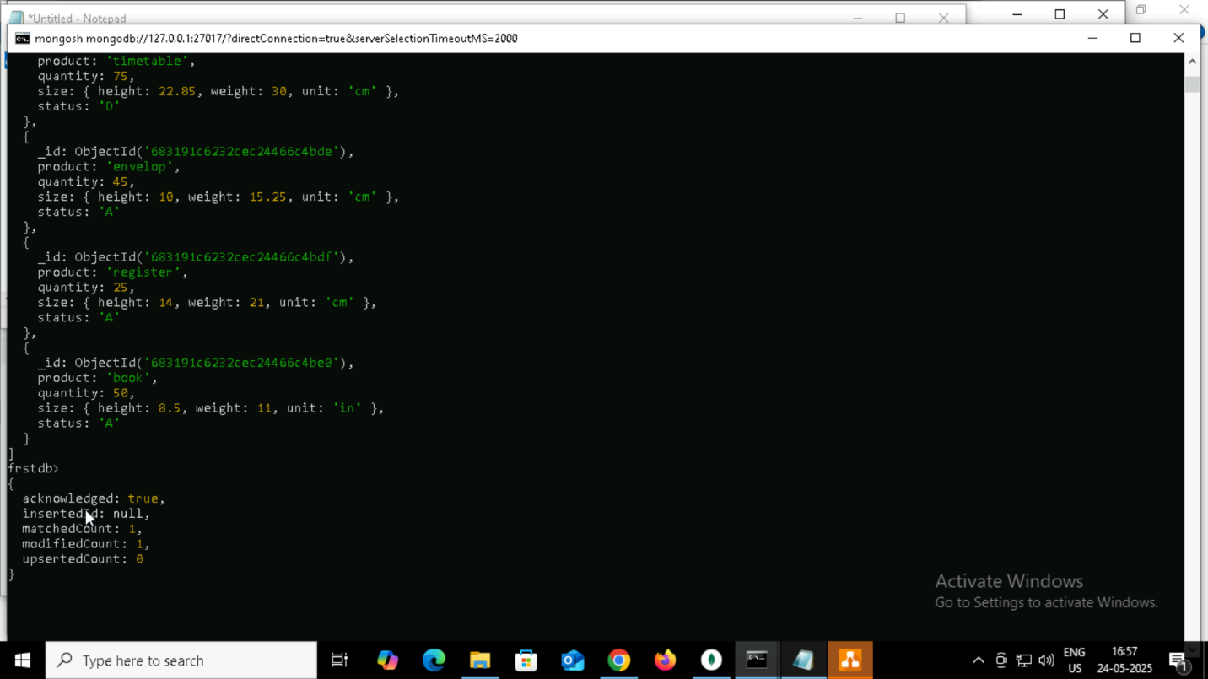
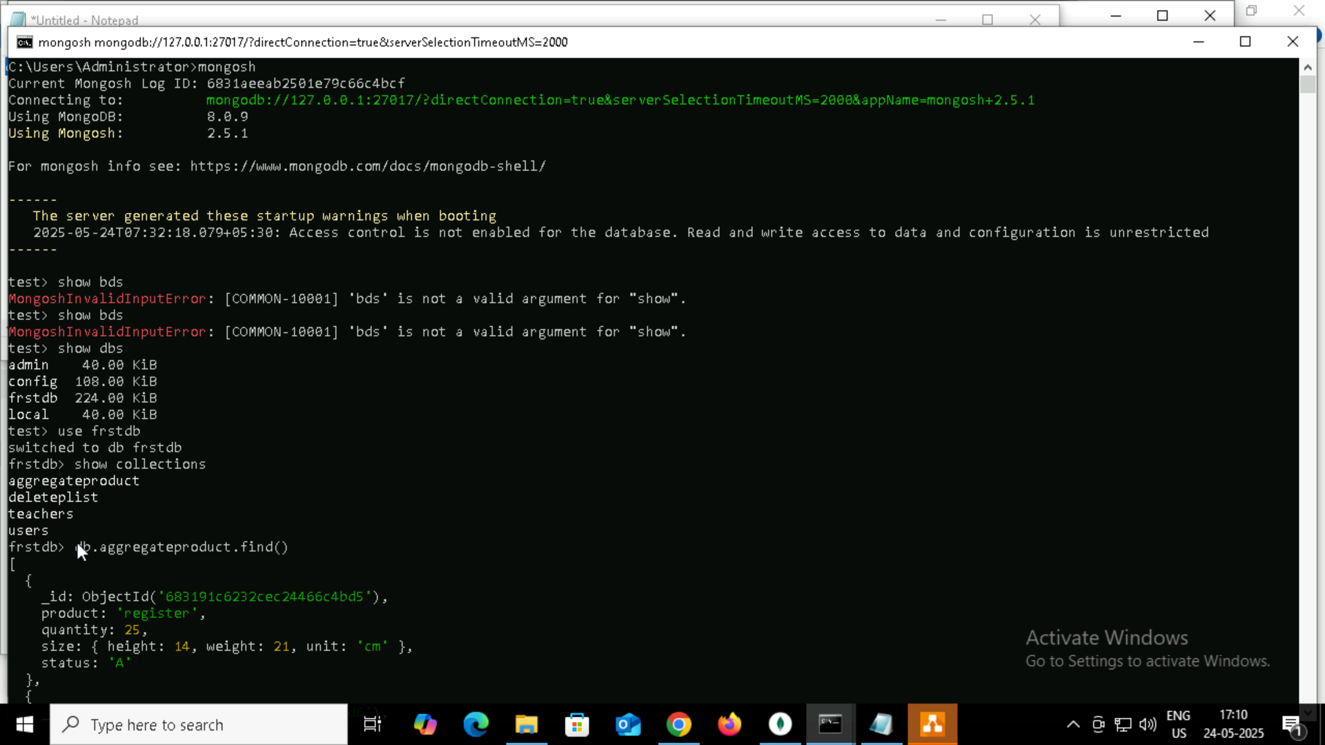

Insert

use firstdb
# this will create db firstdb

#### create collection by 2 ways

db.students.insertOne({name: "kim", age: 12 , standard: "seventh"})
# This is going to create collection students with one document in it.

db.createCollection("teachers")
# This is going to create collection teachers specifically

db.teachers.insertMany([
{
name:"roger",
subject:"maths"
},
{
name:"anita",
subject:"chemistry"
},
{
name:"thomas",
subject:"physics"
},
{
name:"tina",
subject:"maths"
},
{
name:"jonty",
subject:"english"
}
]
)

db.teachers.find()
#this will show all the documents present in the teachers collection

db.teachers.find().forEach(printjson)
# This will print result in json format.

db.teachers.find({name : "roger"})
# this will find the document where name field is "roger"

db.cap2.insertMany(
[
{
_id:14,
name:"sheena",
age:16,
standard:"junior"
},
{
_id:15 ,
name:"kris",
age:18,
standard:"senior"
}
]
)
# This is going to insert 2 entries and since size is capped to 5 entries last entry from collection will get removed.

db.cap2.find()
# this will show only five entries and _id is removed.

db.createCollection("convertcap1")
# create non capped collection

db.runCommand({"convertToCapped": "convertcap1",size : 10000})
#convert a collection to capped one

#Ordered bulk
var bulkOrdered = db.bulk1.initializeOrderedBulkOp()

bulkOrdered.insert({_id:1, name:"Murugan"});
bulkOrdered.insert({_id:2, name:"Niyas"});
bulkOrdered.insert({_id:3, name:"Nitin"});
bulkOrdered.insert({_id:1, name:"Murugan"});
bulkOrdered.insert({_id:4, name:"Adarsh"});
bulkOrdered.execute();

Deleting:
db.deleteplist.insertMany( [
{ product: "register", quantity: 25, size: { height: 14, weight: 21, unit: "cm" }, status: "A" },
{ product: "book", quantity: 50, size: { height: 8.5, weight: 11, unit: "in" }, status: "A" },
{ product: "sheet", quantity: 100, size: { height: 8.5, weight: 11, unit: "in" }, status: "D" },
{ product: "timetable", quantity: 75, size: { height: 22.85, weight: 30, unit: "cm" }, status: "D" },
{ product: "envelop", quantity: 45, size: { height: 10, weight: 15.25, unit: "cm" }, status: "A" }
]);

db.deleteplist.deleteOne( { product: "sheet"} )

db.deleteplist.find( { product: "sheet"} )

db.deleteplist.deleteOne( { size: { height: 14, weight: 21, unit: "cm" } } )

db.deleteplist.find( { size: { height: 14, weight: 21, unit: "cm" } } )

db.deleteplist.deleteMany( { tags: ["red", "blank"] } )

db.deleteplist.deleteMany( { tags: "red" } )

Aggregarte:
db.aggregateproduct.insertMany( [
{ product: "register", quantity: 25, size: { height: 14, weight: 21, unit: "cm" }, status: "A" },
{ product: "book", quantity: 50, size: { height: 8.5, weight: 11, unit: "in" }, status: "A" },
{ product: "sheet", quantity: 100, size: { height: 8.5, weight: 11, unit: "in" }, status: "D" },
{ product: "timetable", quantity: 75, size: { height: 22.85, weight: 30, unit: "cm" }, status: "D" },
{ product: "envelop", quantity: 45, size: { height: 10, weight: 15.25, unit: "cm" }, status: "A" },
{ product: "register", quantity: 25, size: { height: 14, weight: 21, unit: "cm" }, status: "A" },
{ product: "book", quantity: 50, size: { height: 8.5, weight: 11, unit: "in" }, status: "A" },
{ product: "sheet", quantity: 100, size: { height: 8.5, weight: 11, unit: "in" }, status: "D" },
{ product: "timetable", quantity: 75, size: { height: 22.85, weight: 30, unit: "cm" }, status: "D" },
{ product: "envelop", quantity: 45, size: { height: 10, weight: 15.25, unit: "cm" }, status: "A" },
{ product: "register", quantity: 25, size: { height: 14, weight: 21, unit: "cm" }, status: "A" },
{ product: "book", quantity: 50, size: { height: 8.5, weight: 11, unit: "in" }, status: "A" }
]);

db.aggregateproduct.aggregate([
{ $match: { status: "A" } },
{ $group: { _id: "$product", total: { $sum: "$quantity" } } }
])

db.aggregateproduct.aggregate([
{ $match: { status: "A" } },
{ $group: { _id: "$product", total: { $sum: "$quantity" } } },
{$sort : { total : 1 }
}
])

db.aggregateproduct.aggregate([
{ $match: { status: "A" } },
{ $addFields: {
maxWeight: { $max: "$size.weight" },
minSizeHeight: { $min: "$size.height" }
} }
])

db.aggregateproduct.aggregate([
{ $match: { status: "A" } },
{ $addFields: {
maxQ: { $max: "$quantity" },
minSizeHeight: { $min: "$size.height" }
} }
])

db.aggregateproduct.aggregate([
{ $project : { product : 1,quantity : 1 } } , //optional line
{ $group: { _id: "$product", total: { $sum: "$quantity" } } },
{$sort : { total : 1 }
}
])

firstdb> db.aggregateproduct.aggregate([
... { $project : { product : 1,quantity : 1 } } ,
... { $group: { _id: "$product", total: { $sum: "$quantity" } } },
... {$sort : { total : 1 }
... }
... ])
[
{ _id: 'register', total: 75 },
{ _id: 'envelop', total: 90 },
{ _id: 'book', total: 150 },
{ _id: 'timetable', total: 150 },
{ _id: 'sheet', total: 200 }
]
firstdb> db.aggregateproduct.aggregate([{ $group: { _id: "$product", total: { $sum: "$quantity" } } }, { $sort: { total: 1 } }] )
[
{ _id: 'register', total: 75 },
{ _id: 'envelop', total: 90 },
{ _id: 'book', total: 150 },
{ _id: 'timetable', total: 150 },
{ _id: 'sheet', total: 200 }
]

db.collection.mapReduce(
mapfunction() # this give document with key value pairs
reducefunction() # reduces earlier key and value pair to single key and single value pair.

{
query # this is basically same query as we throw it in the find function.
output # end result the way we want to print

})

lets see an example

db.aggregateproduct.mapReduce(
function() {
emit(this.product,1);
},
function(key, values) {
return Array.sum(values);
},
{
query:{status:"A"},
out: { merge: "map_reduce_result" },
}
)
db.map_reduce_result.find();

INDEXING:
db.collection.createIndex( <key and index type specification>, <options> )

db.indexcollection.insertMany( [
{ product: "register", status: "A", size: { height: 14, weight: 21, unit: "cm" }, instock: [ { warehouse: "A", quantity: 5 } ] , creationts: ISODate("2014-11-01T12:30:15Z")},
{ product: "book", status: "A", size: { height: 8.5, weight: 11, unit: "in" }, instock: [ { warehouse: "C", quantity: 5 } ], creationts: ISODate("2016-11-01T12:30:15Z") },
{ product: "sheet", status: "D", size: { height: 8.5, weight: 11, unit: "in" }, instock: [ { warehouse: "A", quantity: 60 } ] , creationts: ISODate("2017-11-01T12:30:15Z")},
{ product: "timetable", status: "D", size: { height: 22.85, weight: 30, unit: "cm" }, instock: [ { warehouse: "A", quantity: 40 } ] , creationts: ISODate("2018-11-01T12:30:15Z")},
{ product: "envelop", status: "A", size: { height: 10, weight: 15.25, unit: "cm" }, instock: [ { warehouse: "B", quantity: 15 }, { warehouse: "C", quantity: 35 } ], creationts: ISODate("2019-11-01T12:30:15Z") },
{ product: "register", status: "A", size: { height: 14, weight: 21, unit: "cm" }, instock: [ { warehouse: "A", quantity: 5 } ] , creationts: ISODate("2014-11-01T12:30:15Z")},
{ product: "register", status: "A", size: { height: 8.5, weight: 11, unit: "in" }, instock: [ { warehouse: "C", quantity: 5 } ], creationts: ISODate("2016-11-01T12:30:15Z") },
{ product: "register", status: "D", size: { height: 8.5, weight: 11, unit: "in" }, instock: [ { warehouse: "A", quantity: 60 } ] , creationts: ISODate("2017-11-01T12:30:15Z")},
{ product: "book", status: "D", size: { height: 22.85, weight: 30, unit: "cm" }, instock: [ { warehouse: "A", quantity: 40 } ] , creationts: ISODate("2018-11-01T12:30:15Z")},
{ product: "book", status: "A", size: { height: 10, weight: 15.25, unit: "cm" }, instock: [ { warehouse: "B", quantity: 15 }, { warehouse: "C", quantity: 35 } ], creationts: ISODate("2019-11-01T12:30:15Z") }
]);

db.indexcollection.getIndexes()
db.indexcollection.dropIndexes()

db.indexcollection.createIndex( { product: 1 } )
db.indexcollection.getIndexes()

db.largecollectionforindex.createIndex( { product: 1 } )
db.indexcollection.createIndex( { "size.height": 1 } )

db.indexcollection.find( { "size.height" : 8.5 } )

db.indexcollection.createIndex( { size: 1 } )

db.indexcollection.find( {size: { height: 10, weight: 15.25, unit: "cm" } } )

db.collection.createIndex( { <field1>: <type>, <field2>: <type2>, ... } )

db.indexcollection.createIndex( { status : 1 , "size.height": 1 } )

db.indexcollection.getIndexes()

db.indexcollection.find( { product: 1 , "size.height": 1 } )

db.indexcollection.find( { product: -1 , "size.height": -1 } )

but below is not supported well

db.indexcollection.find( { product: 1 , "size.height": -1 } )

or

db.indexcollection.find( { product: -1 , "size.height": 1 } )

db.indexcollection.createIndex( { instock: 1 } )
db.indexcollection.find( { instock : [ { warehouse: "B", quantity: 15 }, { warehouse: "C", quantity: 35 } ] } )
db.indexcollection.createIndex( { product : 1, instock: 1 } )

db.indexcollection.createIndex( { _id: "hashed" } )

db.indexcollection.find( { instock: [ { warehouse: "B", quantity: 15 } ] } )

db.indexcollection.createIndex( { product: "text" } )

db.indexcollection.createIndex( { product: "text" , status : "text" } )

db.indexcollection.createIndex( { "$**": "text" } )

db.indexcollection.createIndex( {"size.weight" : 1, "$**": "text" } )

db.collection.createIndex( { <location field> : "2dsphere" } )

db.geoplaces.insertMany([
{
name: "Muncipal Park",
location: { type: "Point", coordinates: [ -73.97, 40.77 ] },
category: "Parks"
} ,
{
name: "City Park",
location: { type: "Point", coordinates: [ -73.9928, 40.7193 ] },
category: "Parks"
},
{
name: "kannedy Grounds",
location: { type: "Point", coordinates: [ -73.9375, 40.8303 ] },
category: "Stadiums"
}
]
);

db.geoplaces.find(
{
location:
{ $near:
{
$geometry: { type: "Point", coordinates: [ -73.9667, 40.78 ] },
$minDistance: 1000,
$maxDistance: 5000
}
}
}
)

db.geoplaces.createIndex( { location: "2dsphere" } )

Regex
db.regex.insertMany([{
name: "Tony",
position: "Backend developer"
}
{
name: "Bruce",
position: "frontend developer"
}
{
name: "Nick",
position: "HR Manager"
}
])
db.geoplaces.find({
{ <field>: { $regex: /pattern/, $options: '<options>' } }
{ <field>: { $regex: 'pattern', $options: '<options>' } })

